Requirements/Design Specification

**May 2015 Bug Fixes**

Revision History

|  |  |  |  |
| --- | --- | --- | --- |
| **Date** | **Revision** | **Description** | **Author** |
| 3/12/2015 | 1.0 | Initial Version with Requirements | Roger Behm |
|  |  |  |  |
|  |  |  |  |
|  |  |  |  |
|  |  |  |  |

The information furnished herein by Republic Services Inc. is proprietary and confidential to Republic Services Inc. personnel and is not to be duplicated, published, or disclosed to any third party in whole or in part without permission from Republic Services, Inc.

© Copyright 2012, Republic Services Inc. - All rights reserved.

Table of contents

1 Business Requirements 6

1.1 Purpose of the Design Specification 6

1.1.1 Bug list for current release 6

2 Assumptions 6

3 Design 6

3.1 #458 Existing Customer New Container VCD not on CSA if CSA box is not checked 6

3.2 #420 Disposal Site Missing - Correct in CMC, Showing in Test, Missing in Prod 6

3.3 #407 Admin fee on Customer Facing CSA waived for existing customer with Admin fee yes 7

3.4 #291 Divisions that don't charge Admin fees bug 7

4 InfoPro Interface 8

5 Report Changes 8

6 Appendix 8

# Business Requirements

## Purpose of the Design Specification

This document highlights items to be fixed and implemented for the titled release. Most of these issues are bug fixes to be fixed by code logic. No new attributes are planned and existing attributes should not be repurposed.

### Bug list for current release

| GitHub Item  Number | **Description** |
| --- | --- |
| 458 | Existing Customer New Container VCD not on CSA if CSA box is not checked |
| 420 | Disposal Site Missing - Correct in CMC, Showing in Test, Missing in Prod |
| 407 | Admin fee on Customer Facing CSA waived for existing customer with Admin fee yes |
| 291 | Divisions that don't charge Admin fees bug |

# 

# Assumptions

NA

# Design

## #458 Existing Customer New Container VCD not on CSA if CSA box is not checked

**Issue**

If you do a quote for an existing customer and add a new container with a VCD but do not click on the CSA box on the Generate Docs page, you are able to finalize and the VCD will not show up on the notes.

**Design**

Display the VCD on the office use CSA regardless of the customer CSA was printed. Add validation for existing customers to ensure the customer CSA checkbox on the Generate Docs page is checked.

**BI or InfoPro**

No Impact

## #420 Disposal Site Missing - Correct in CMC, Showing in Test, Missing in Prod

**Issue**

Disposal Site Missing from Prod, yet appears to be set up correctly in CMC and is also showing in Test.

**Design**

Check the constraint rules in prod vs test. Move them into the commerce engine so they are migrated automatically.

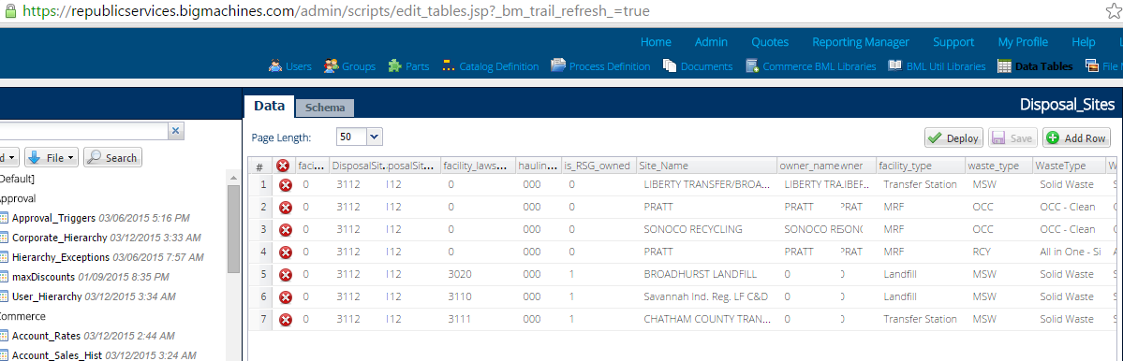

**BI or InfoPro**

No Impact

## #407 Admin fee on Customer Facing CSA waived for existing customer with Admin fee yes

**Issue**

If an existing customer that is charged Admin fee adds service or site the customer facing CSA will show exempt from admin fee. This is misleading to customer who could claim that the contract shows he does not pay the admin fee.

**Design**

The exempt from Admin Fee should only show up if the Admin checkbox (pricing page) is unchecked. This is working for New but not Existing.

**BI or InfoPro**

No Impact

## #291 Divisions that don't charge Admin fees bug

**Issue**

For the divisions that do not charge Admin fees for New/New - the box is checked and the header shows Admin fee yes. The value is $0 so the Finalized CSA shows No Admin fee. However the auto upload into InfoPro is tagging the Admin fee as Yes.

**Design**

Gray out or hid checkbox, defaulted to unchecked if $0 fees.   
comp will add variable to not deduct for $0 fees (GH #383)

**BI or InfoPro**

No Impact

# InfoPro Interface

No new variable should be needed and no existing variables should be repurposed for any of the above changes.

# Report Changes

NA

# Appendix